A MINI PRORJECT REPORT ON

# STUDENT RESULT MANAGEMENT SYSTEM

Submitted By

|  |  |
| --- | --- |
| **Name of Student** | **PRN Number** |
| **NIKITA P.BHOKARE**  **RIYA P.GOLEKAR**  **RITUJA K.KUNDALWAL** | **2010121245041**  **2010121245045**  **2010121245044** |
|  |  |
|  |  |
|  |  |
|  |  |
|  |  |

Under the guidance of

### PROF. PATIL SIR



**DEPARTMENT OF COMPUTER ENGINEERING GOVERNMENT COLLEGE OF ENGINEERING, YAVATMAL**

**2022-2023**

### CERTIFICATE

This is to certify that the mini project report entitled

### “STUDENT RESULT MANAGEMENT SYSTEM”

is a bonafide work and it is submitted to Government College of Engineering, Yavatmal SUBMITTED BY:

NIKITA P. BHOKARE

RIYA P.GOLEKAR

RITUJA K.KUNDALWAL

|  |  |  |
| --- | --- | --- |
|  |  |  |
|  |  |  |
|  |  |  |
|  |  |  |

The report has been approved as it satisfies the academic requirements in respect of mini project work prescribed the course.

Prof.

**(Prof.Patil Sir)**

Department of Computer Engineering Government College of Engineering, Yavatmal

Prof. S. S. Thorat

**(Head of the Department)**

Department of Computer Engineering Government College of Engineering,

Yavatmal

### Dr. P. M. Khodke

(Principal)

Government College of Engineering, Yavatmal



**DEPARTMENT OF COMPUTER ENGINEERING GOVERNMENT COLLEGE OF ENGINEERING, YAVATMAL**

## 2022-2023

### DEPARTMENT OF COMPUTER ENGINEERING GOVERNMENT COLLEGE OF ENGINEERING YAVATMAL



This is to certify th

SYSTEM ENVIRONMENT

Top of Form

Hardware Configuration

1. Pentium IV Processor

2. 512 MB RAM

3. 40GB HDD

4. 1024 * 768 Resolution Color Monitor

Note: This is not the “System Requirements”.

Software Configurati

Hardware Configuration

1. Pentium IV Processor

2. 512 MB RAM

3. 40GB HDD

4. 1024 * 768 Resolution Color Monitor

Note: This is not the “System Requirements”.

Software Conf

Software Configuration

1. OS: Windows XP

2 PHP (PHP5.6. MySQL, Apache, and PHPMy Admin)

**Design**

INTRODUCTION:

Design is the first step in the development phase for any techniques and principles for the purpose of defining a device, a process or system in sufficient detail to permit its physical realization.

Once the software requirements have been analyzed and specified the software design involves three technical activities - design, coding, implementation and testing that are required to build and verify the software.

The design activities are of main importance in this phase, because in this activity, decisions ultimately affecting the success of the software implementation and its ease of maintenance are made. These decisions have the final bearing upon reliability and maintainability of the system. Design is the only way to accurately translate the customer's requirements into finished software or a system.

Design is the place where quality is fostered in development. Software design is a process through which requirements are translated into a representation of software. Software design is conducted in two steps. Preliminary design is concerned with the transformation of requirements into data.

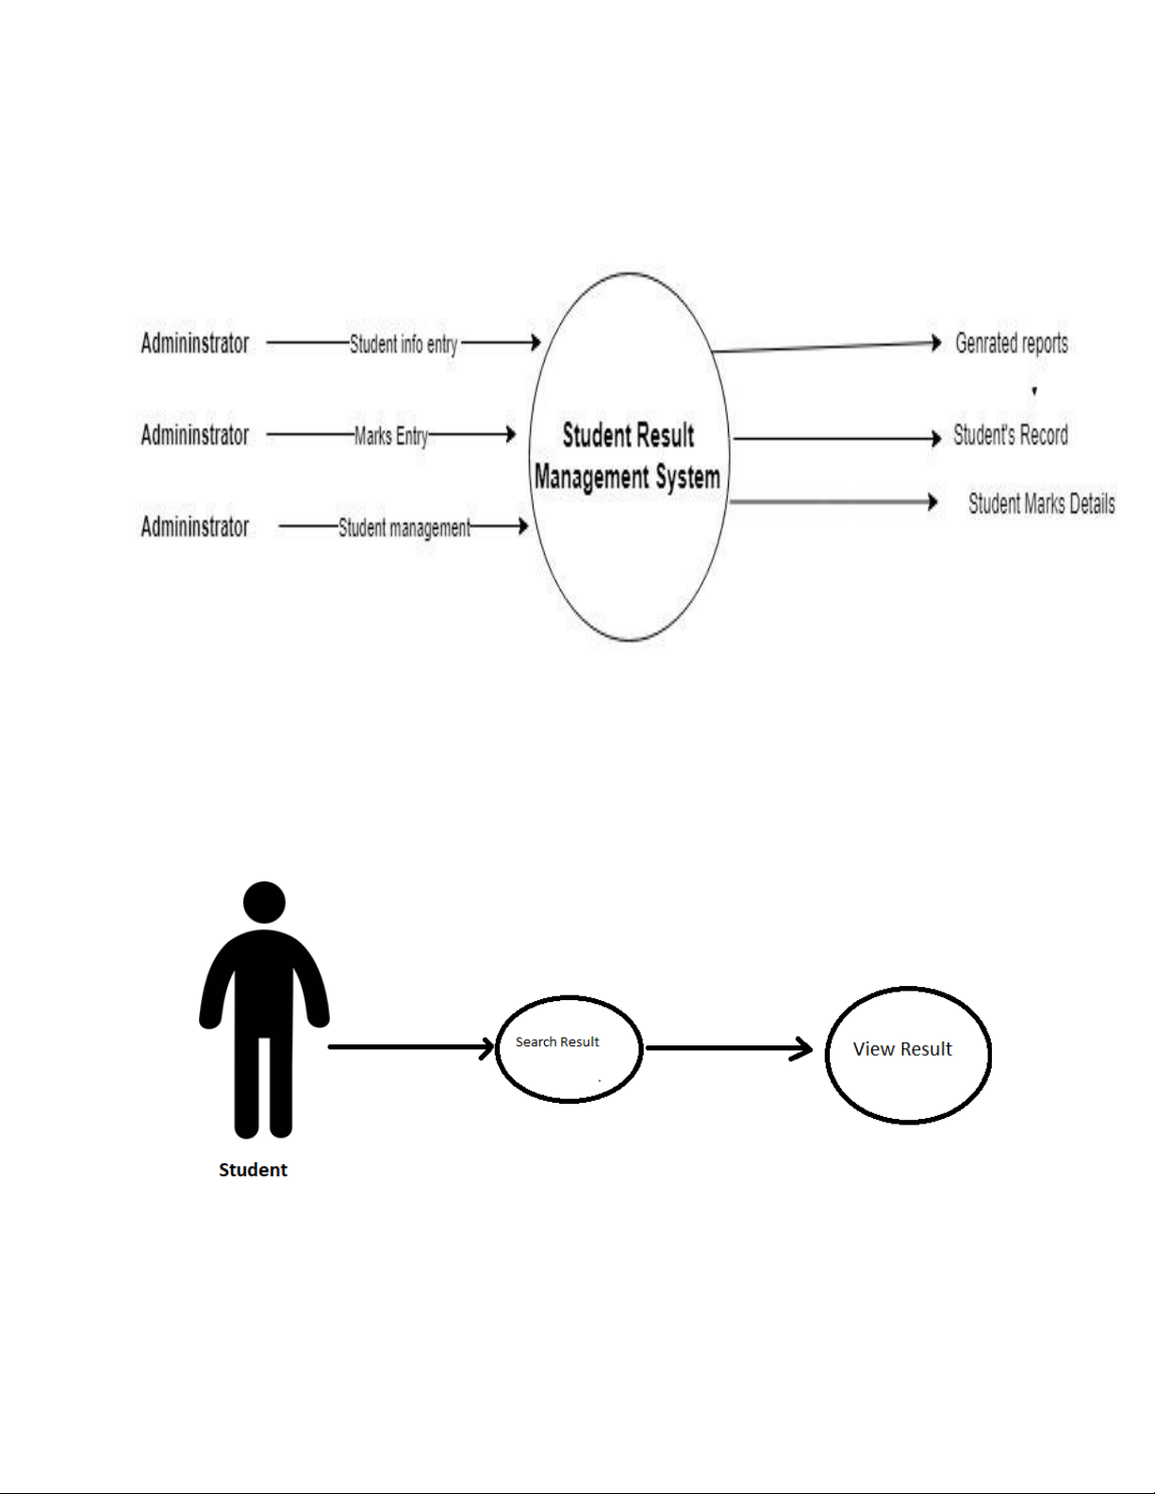

Student case Diagram:

Context Diagram:

Admin Case Diagram:

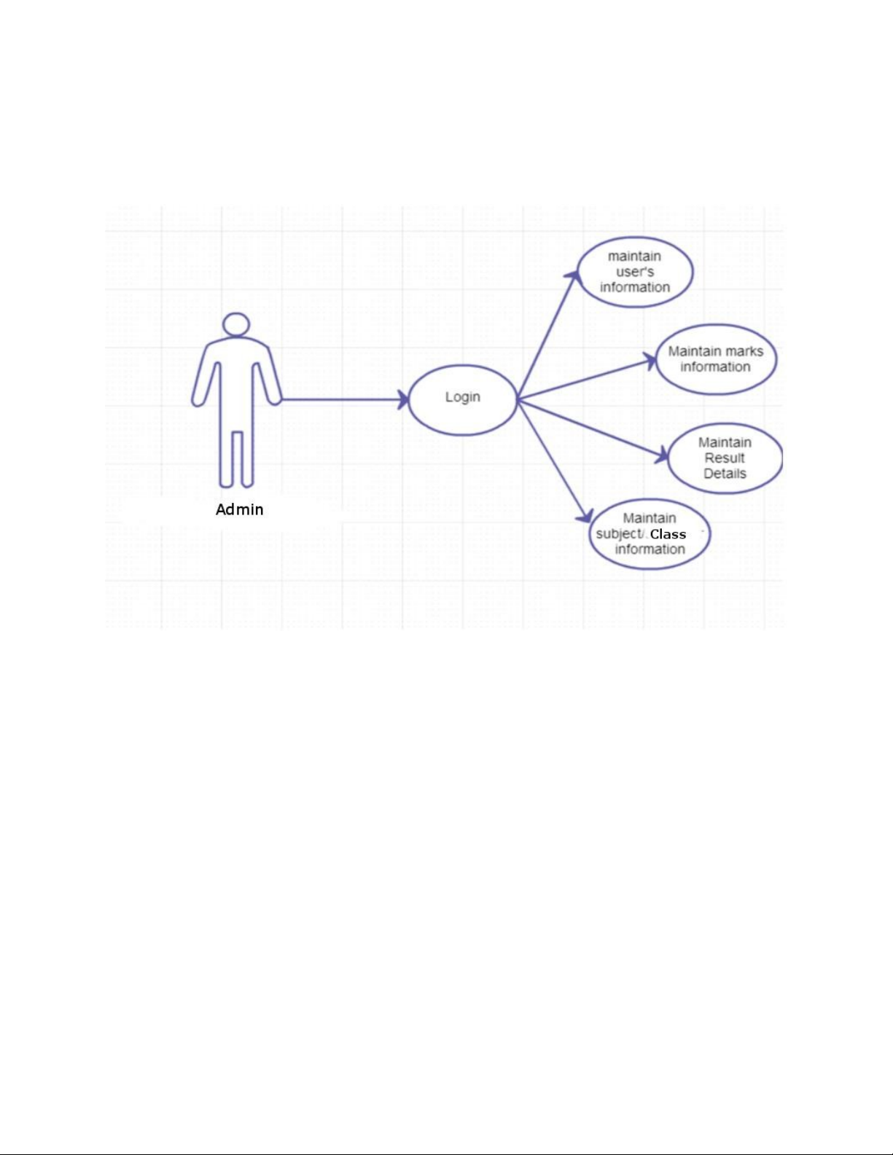

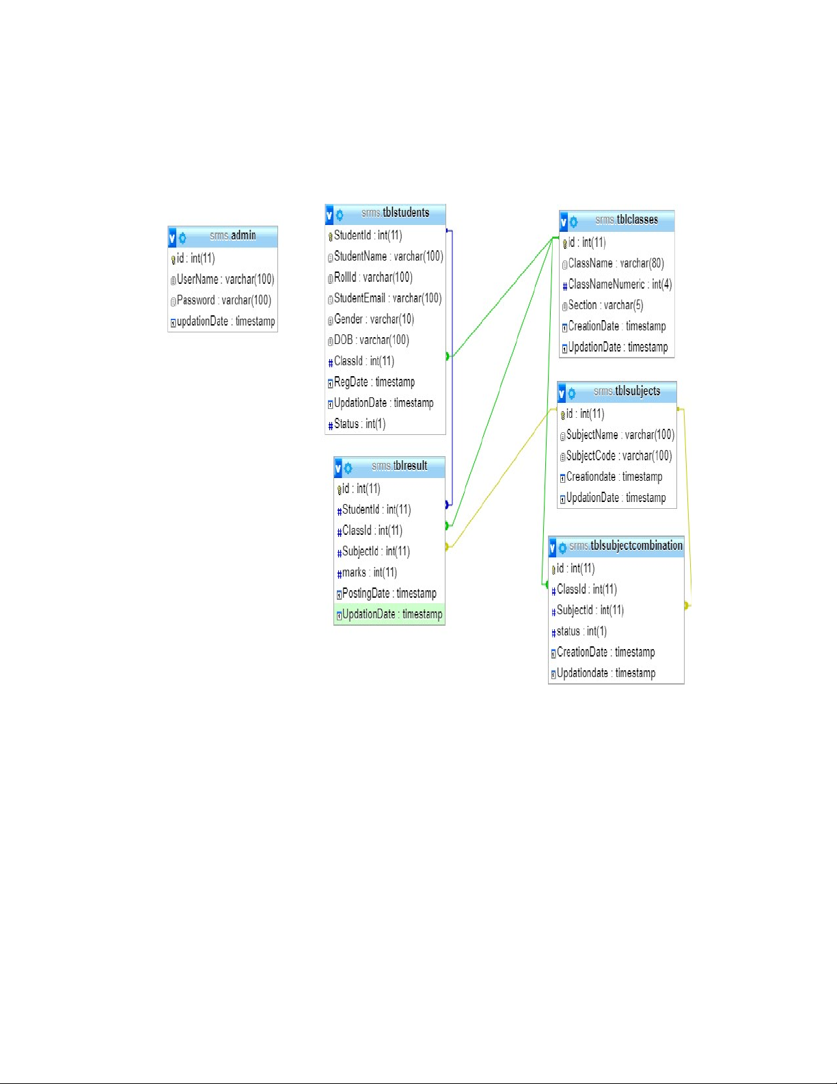

Relationship Diagram Between tables:

OVERVIEW OF TECHNOLOGIES USED

Front End Technology:

HTML:

CSS:

Back End Technology:

PHP

PHP is a server-side scripting language designed specifically for the web.

Within an HTML page, you can embed PHP code that will be executed each time the page is visited. Your PHP code is interpreted at the web server and generates HTML or other output that the visitor will see.

PHP was introduced in 1994. As of November 2007, it was installed on more than 21 million domains worldwide, and this number is growing rapidly. You can see the current number at http://www.php.net/usage.php

PHP is an Open Source project. PHP originally stood for Personal Home Page and now stands for PHP Hypertext Preprocessor.

*Unique Features:*

If you are familiar with other server side language like ASP.NET or JSP you might be wondering what makes PHP so special, or so different from these competing alternatives well, here are some reasons:

1. Performance

2. Portability(Platform Independent)

3. Ease Of Use

4. Open Source

5. Third-Party Application Support

6. Community Support